Nonagon
# Source: AI Source: Provided by: [Data Path: Persons Table -> ID Column: 1, Name_En Column: Motasem Essam] -> From: [ChatGPT] on [7/25/2026]
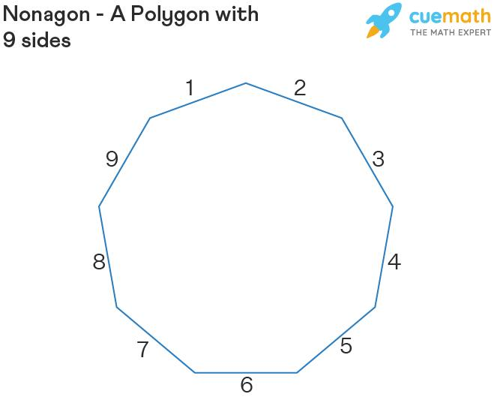
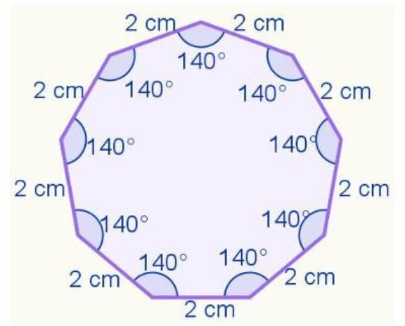
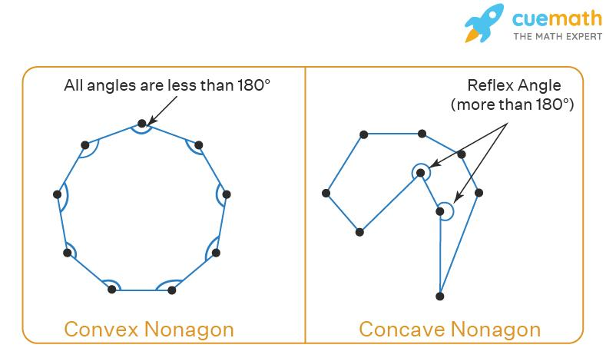
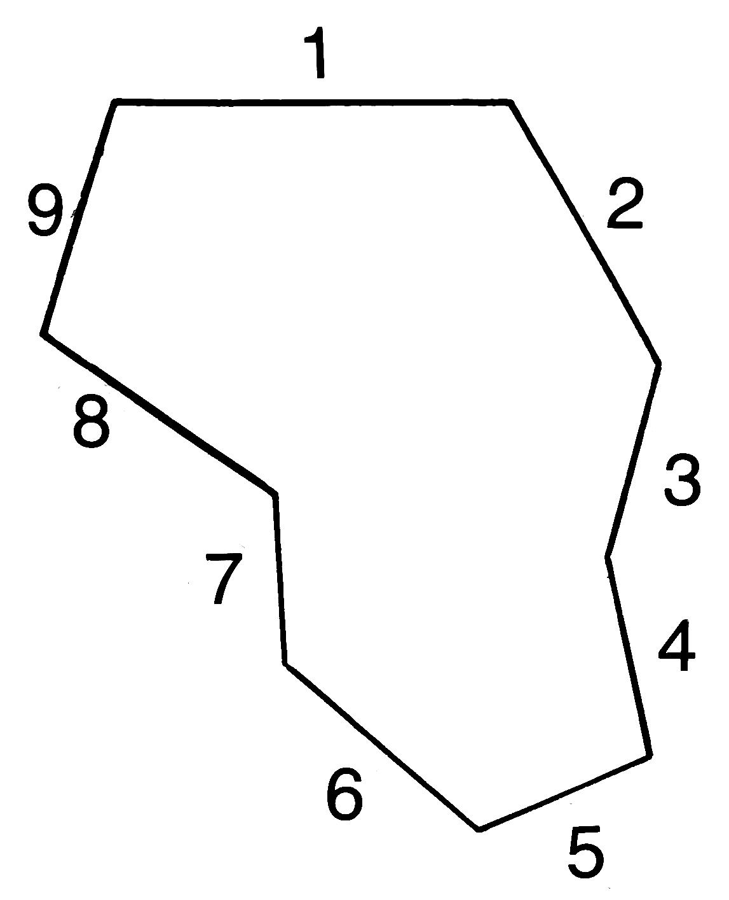

Definition
# Source: AI Source: Provided by: [Data Path: Persons Table -> ID Column: 1, Name_En Column: Motasem Essam] -> From: [ChatGPT] on [7/25/2026]
A nonagon is a polygon with nine straight sides.
Therefore, a nonagon has:
- 9 sides
- 9 vertices
- 9 interior angles
- 9 exterior angles
- 27 diagonals
A nonagon may be convex or concave, regular or irregular, and symmetric or asymmetric.

Fundamental Elements
# Source: AI Source: Provided by: [Data Path: Persons Table -> ID Column: 1, Name_En Column: Motasem Essam] -> From: [ChatGPT] on [7/25/2026]
Consider a nonagon $ABCDEFGHI$:
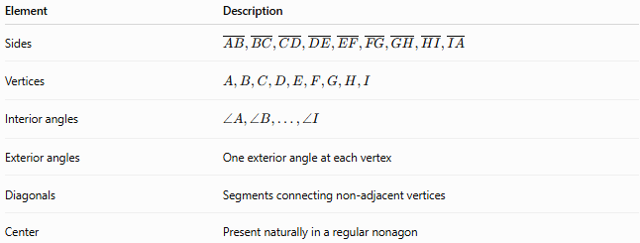
Element | Description
Sides | $$\overset{‾}{AB},\overset{‾}{BC},\overset{‾}{CD},\overset{‾}{DE},\overset{‾}{EF},\overset{‾}{FG},\overset{‾}{GH},\overset{‾}{HI},\overset{‾}{IA}$$
Vertices | $$A,B,C,D,E,F,G,H,I$$
Interior angles | $$∠A,∠B,…,∠I$$
Exterior angles | One exterior angle at each vertex
Diagonals | Segments connecting non-adjacent vertices
Center | Present naturally in a regular nonagon

Classification of Nonagons
# Source: AI Source: Provided by: [Data Path: Persons Table -> ID Column: 1, Name_En Column: Motasem Essam] -> From: [ChatGPT] on [7/25/2026]
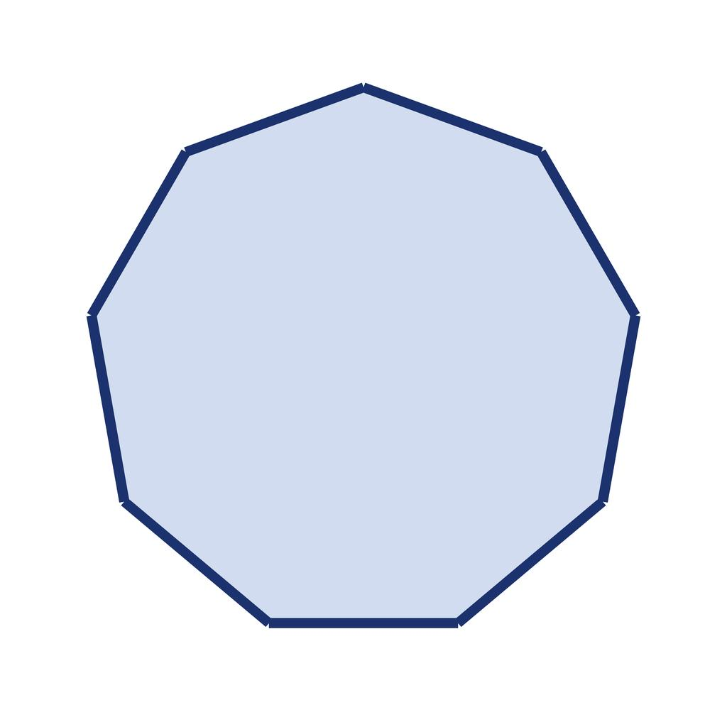
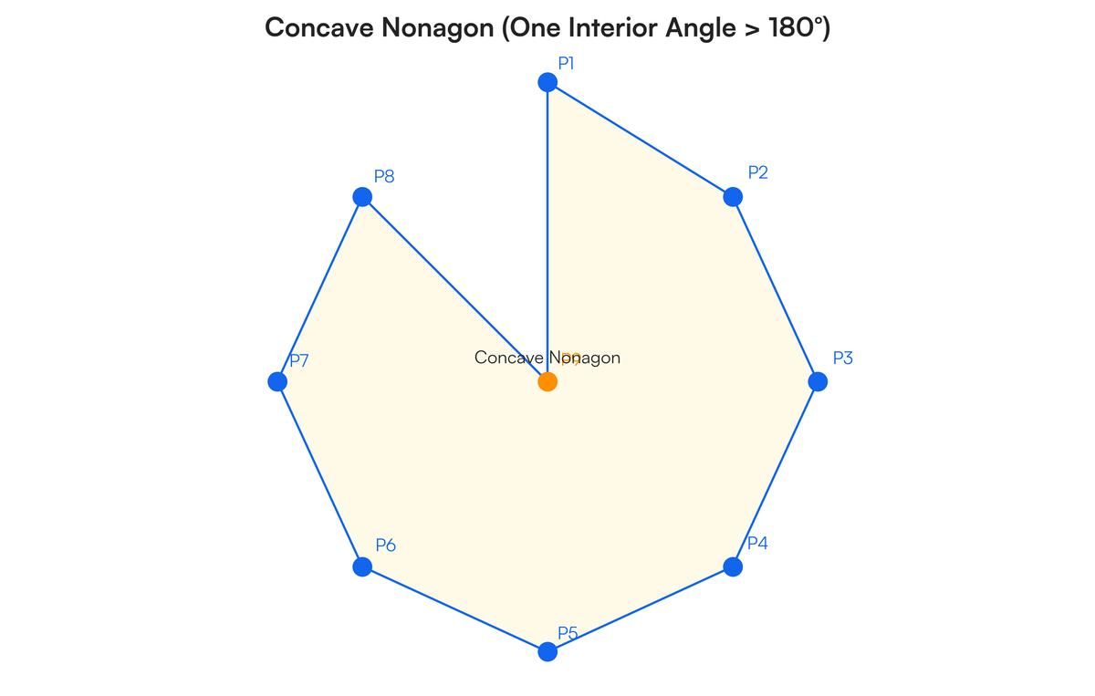
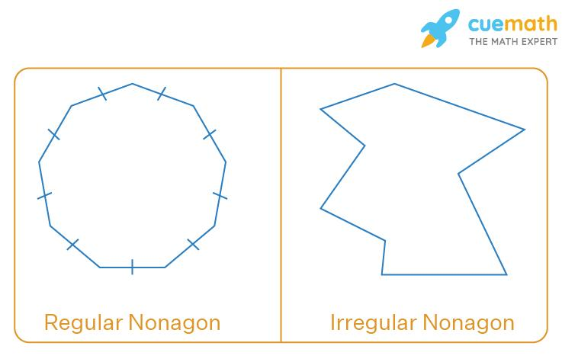
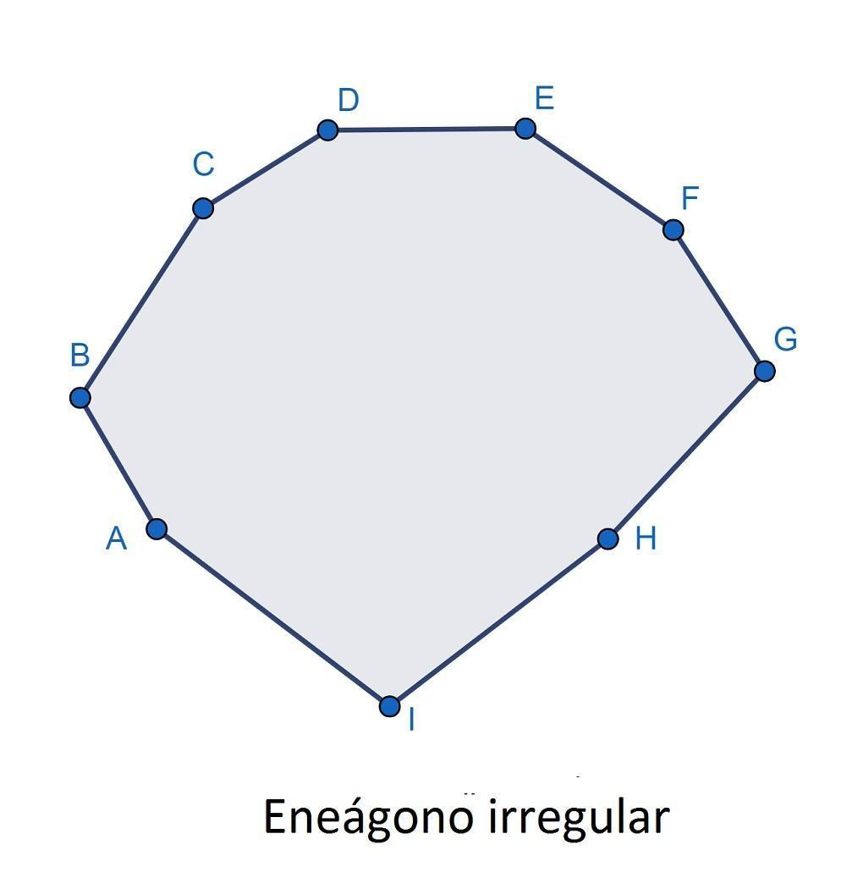
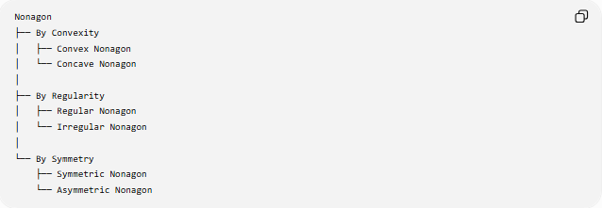
Nonagon
├── By Convexity
│ ├── Convex Nonagon
│ └── Concave Nonagon
│
├── By Regularity
│ ├── Regular Nonagon
│ └── Irregular Nonagon
│
└── By Symmetry
├── Symmetric Nonagon
└── Asymmetric Nonagon

Convex Nonagon
# Source: AI Source: Provided by: [Data Path: Persons Table -> ID Column: 1, Name_En Column: Motasem Essam] -> From: [ChatGPT] on [7/25/2026]
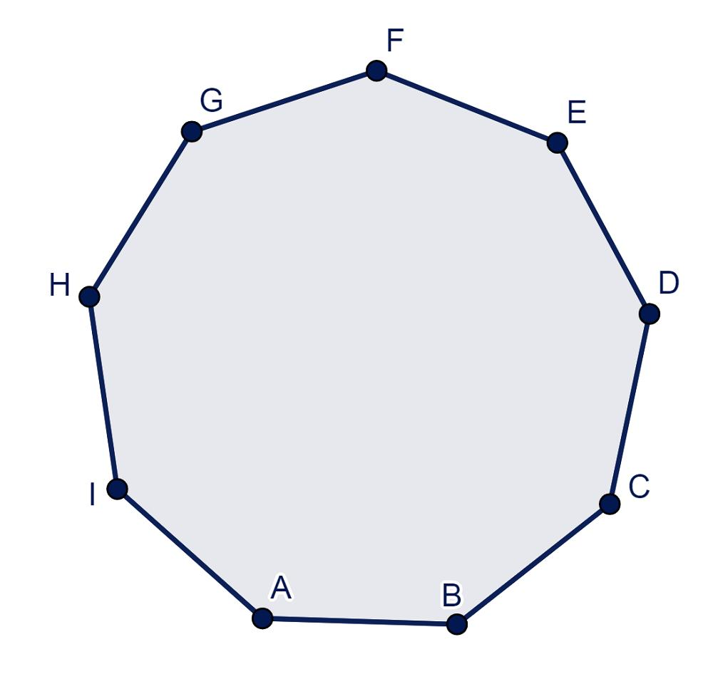
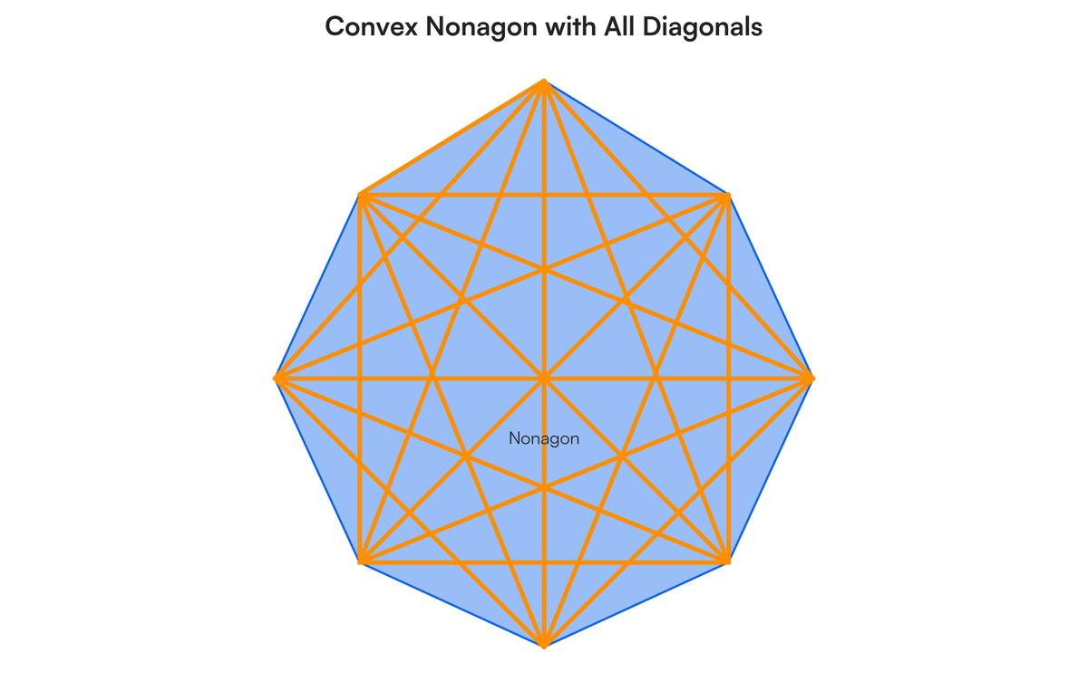
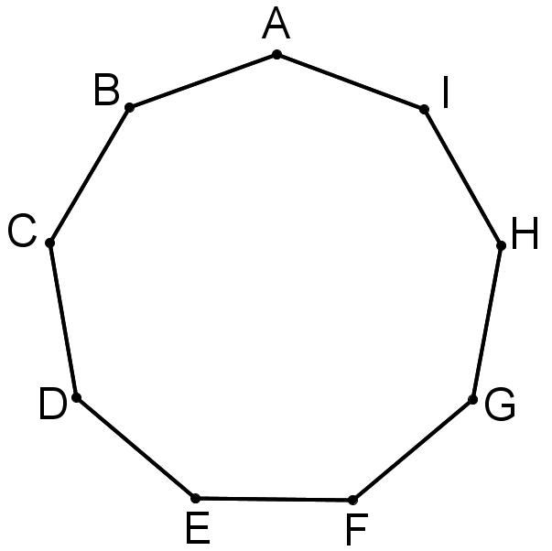
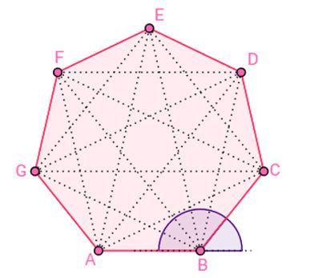
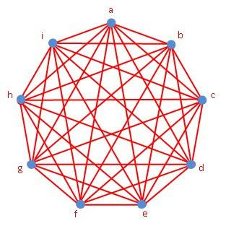
A convex nonagon is a nonagon in which every interior angle is less than ${180}^{∘}$.
Properties
- All 9 interior angles are $<{180}^{∘}$.
- It has no inward indentation.
- Every diagonal lies completely inside the nonagon.
- Every line segment connecting two points of the nonagon remains inside it.

Concave Nonagon
# Source: AI Source: Provided by: [Data Path: Persons Table -> ID Column: 1, Name_En Column: Motasem Essam] -> From: [ChatGPT] on [7/25/2026]
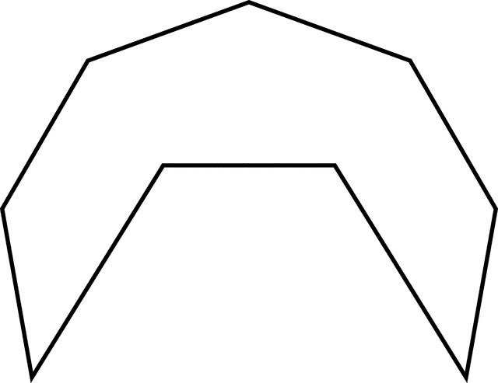
A concave nonagon is a nonagon with at least one interior angle greater than ${180}^{∘}$.
Properties
- At least one interior angle is $>{180}^{∘}$.
- It has an inward indentation.
- At least one diagonal lies partly outside the nonagon.
- It is not convex.

Regular Nonagon
# Source: AI Source: Provided by: [Data Path: Persons Table -> ID Column: 1, Name_En Column: Motasem Essam] -> From: [ChatGPT] on [7/25/2026]
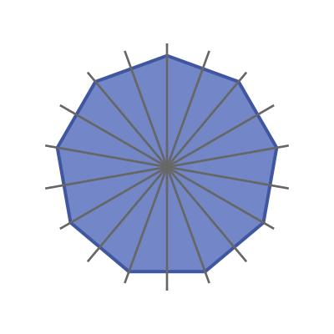
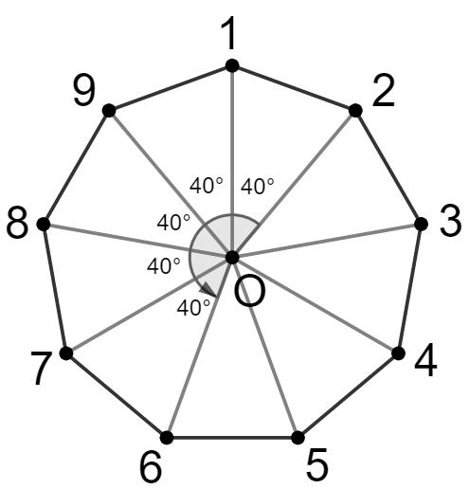
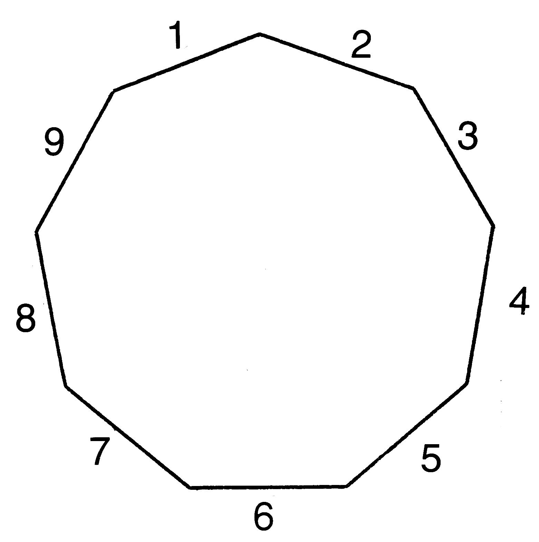
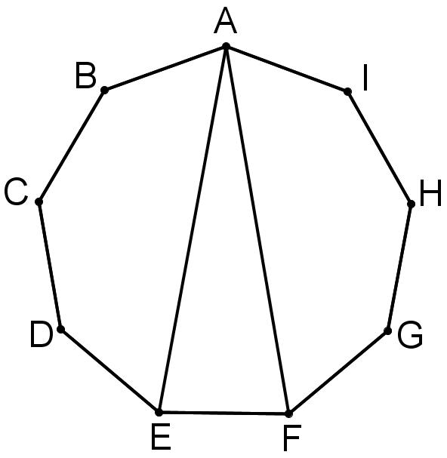
A regular nonagon has:
- 9 equal sides
- 9 equal interior angles
Interior Angle Sum
For any nonagon:
$$\left(9-2\right)×{180}^{∘}={1260}^{∘}$$
Therefore, each interior angle of a regular nonagon is:
$$\frac{{1260}^{∘}}{9}=\boxed{{140}^{∘}}$$
Exterior Angle
$$\frac{{360}^{∘}}{9}=\boxed{{40}^{∘}}$$
Central Angle
$$\frac{{360}^{∘}}{9}=\boxed{{40}^{∘}}$$
Perimeter
If each side has length $a$:
$$\boxed{P=9a}$$
Area
For a regular nonagon:
$$\boxed{A=\frac{9a^{2}}{4}\cot\left(\frac{{20}^{∘}}{1}\right)}$$
Equivalently:
$$\boxed{A=\frac{9a^{2}}{4\tan{{20}^{∘}}}}$$
Symmetry
A regular nonagon has:
- 9 lines of symmetry
- Rotational symmetry of order 9
- Smallest rotational angle: ${40}^{∘}$

Irregular Nonagon
# Source: AI Source: Provided by: [Data Path: Persons Table -> ID Column: 1, Name_En Column: Motasem Essam] -> From: [ChatGPT] on [7/25/2026]
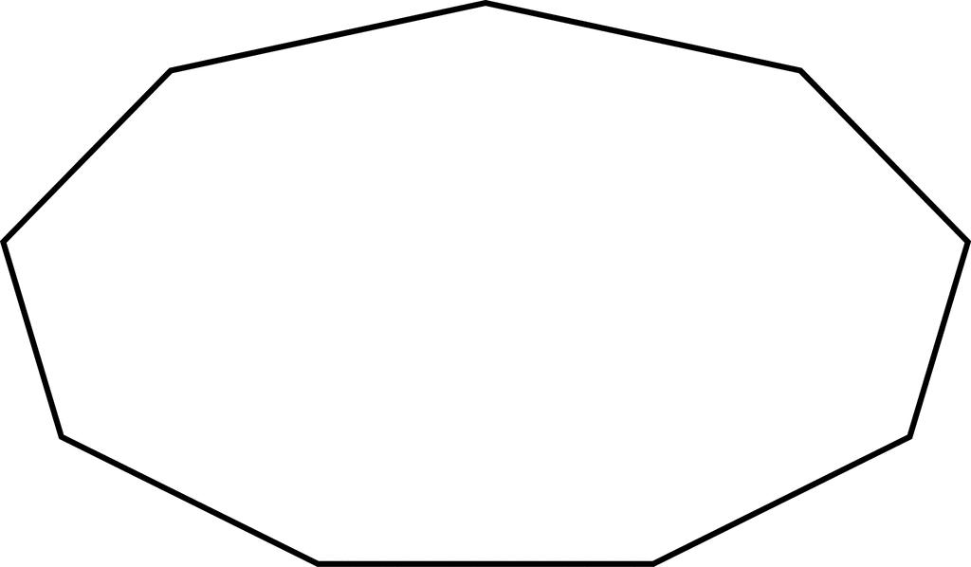
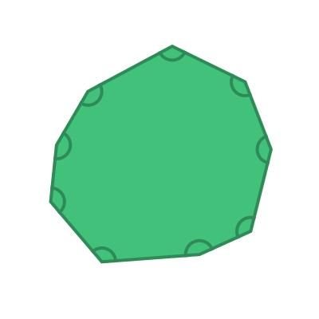
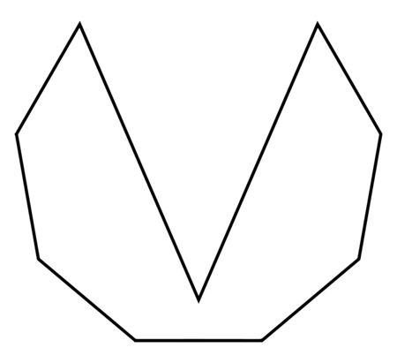
An irregular nonagon is a nonagon that does not have all nine sides and all nine angles equal.
It may have:
- Different side lengths
- Different angle measures
- Some equal sides
- Some equal angles
- Reflection symmetry
- Rotational symmetry
- No symmetry
An irregular nonagon may be either convex or concave.

Symmetric Nonagon
# Source: AI Source: Provided by: [Data Path: Persons Table -> ID Column: 1, Name_En Column: Motasem Essam] -> From: [ChatGPT] on [7/25/2026]
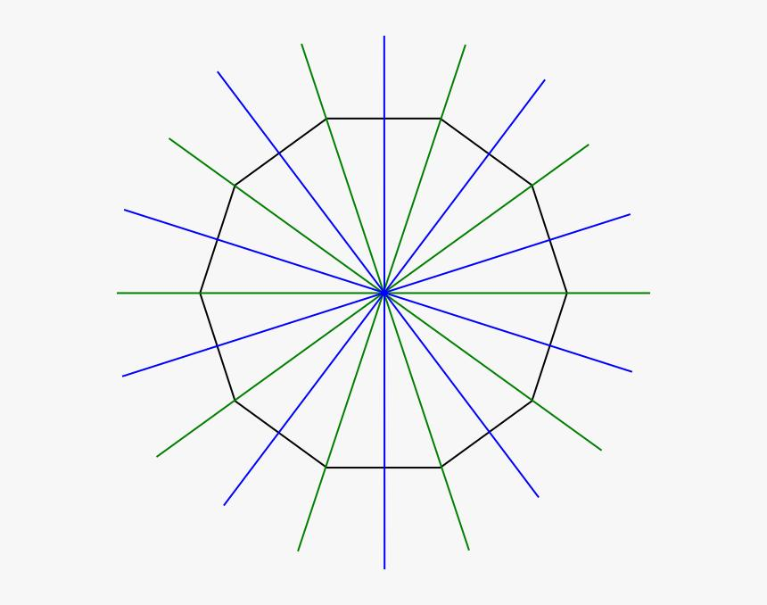
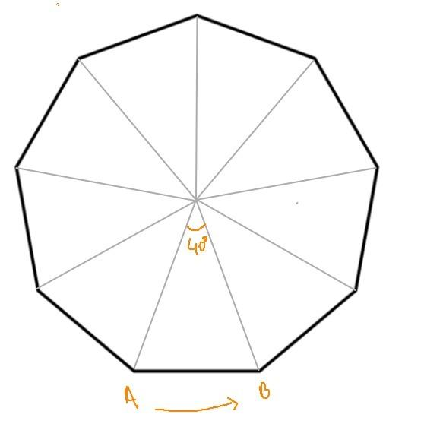
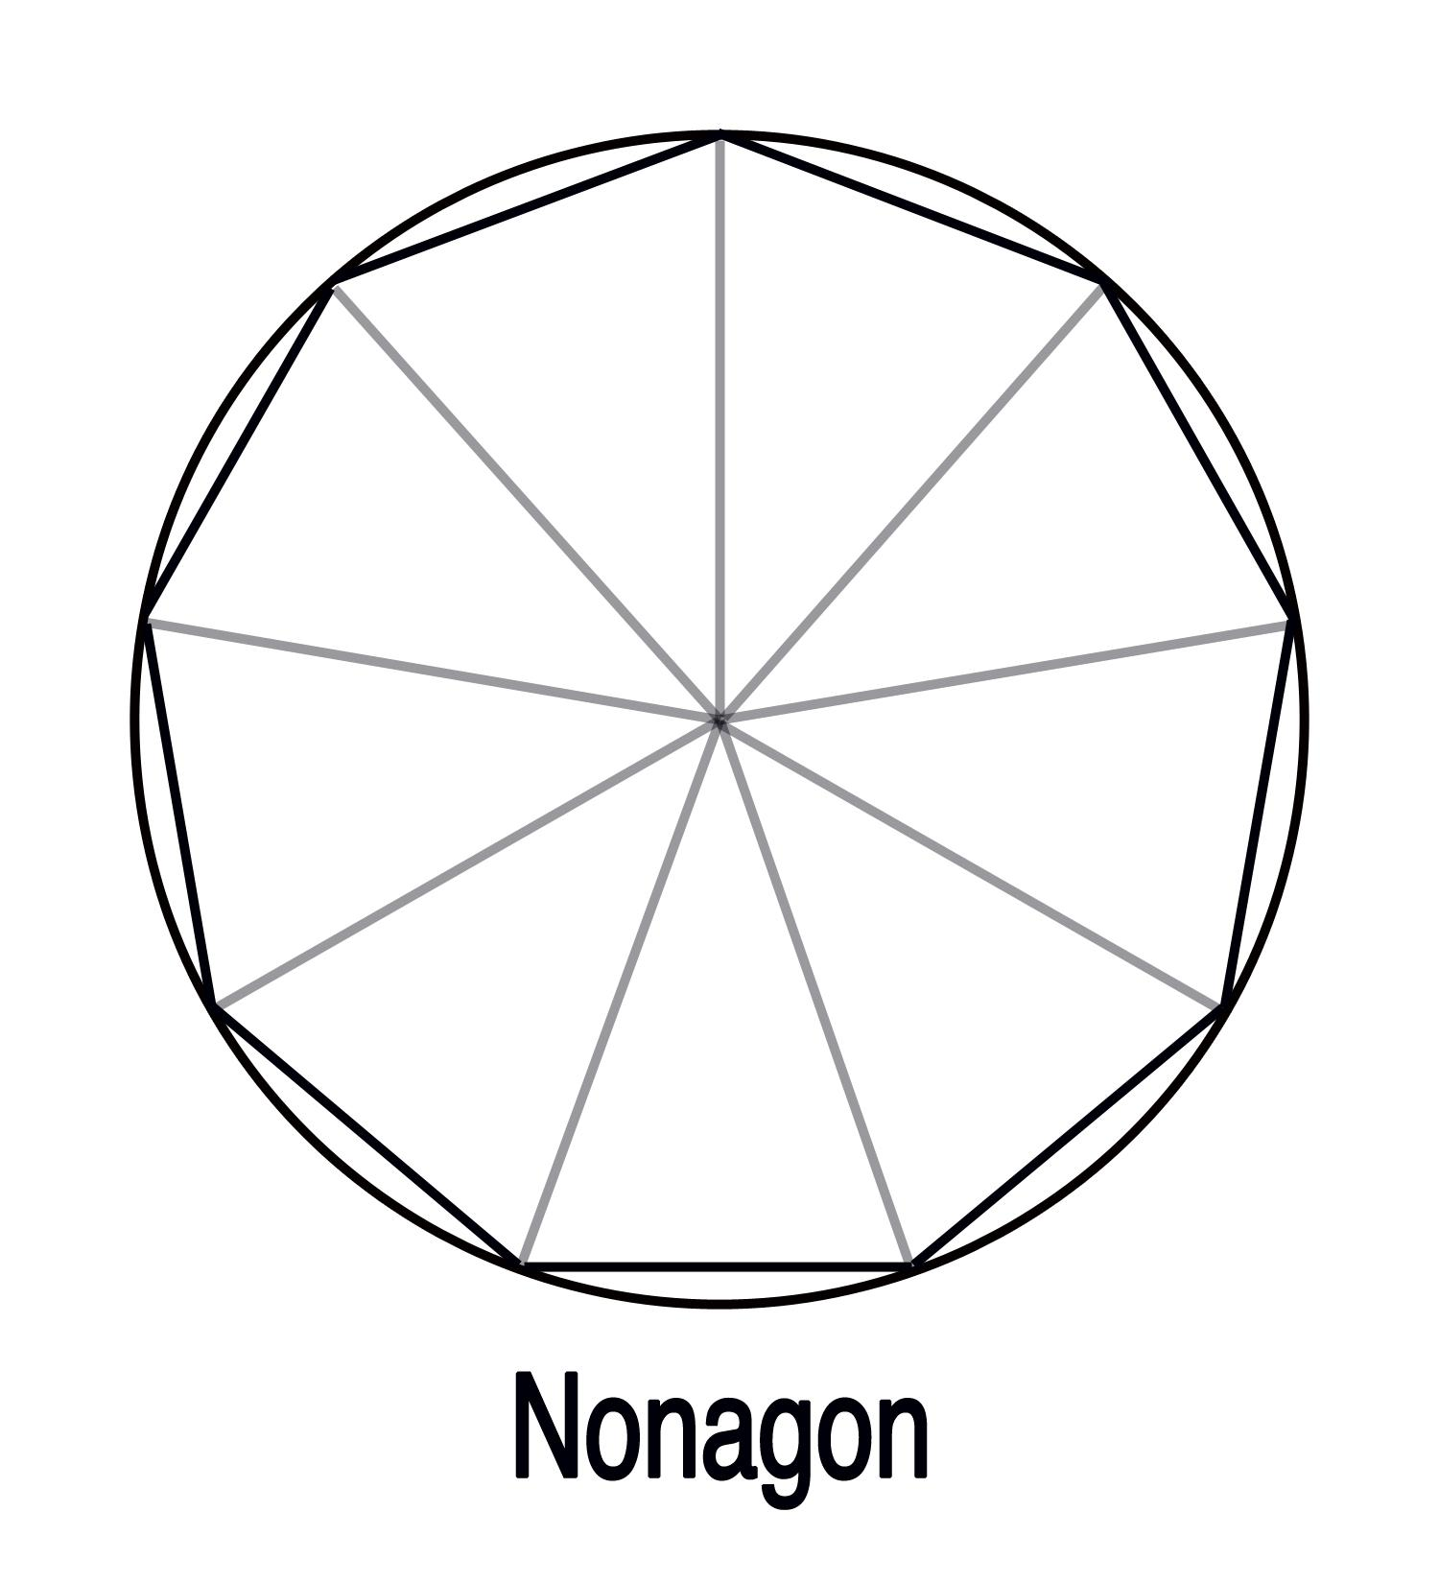
A symmetric nonagon has at least one nontrivial symmetry.
It may have:
- Reflection symmetry
- Rotational symmetry
- Or both
A regular nonagon has 9 lines of reflection symmetry and rotational symmetry of order 9.

Asymmetric Nonagon
# Source: AI Source: Provided by: [Data Path: Persons Table -> ID Column: 1, Name_En Column: Motasem Essam] -> From: [ChatGPT] on [7/25/2026]
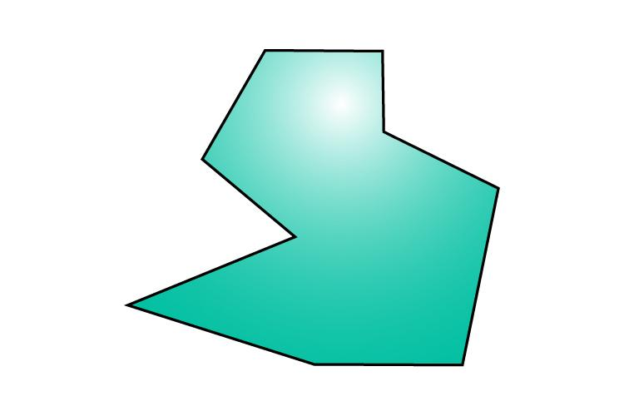
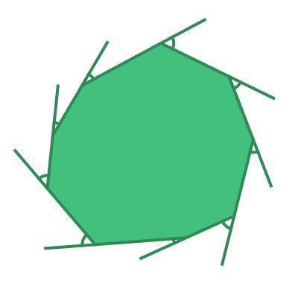
An asymmetric nonagon has:
- No line of reflection symmetry
- No nontrivial rotational symmetry
It can still be convex or concave.

Interior Angle Sum
# Source: AI Source: Provided by: [Data Path: Persons Table -> ID Column: 1, Name_En Column: Motasem Essam] -> From: [ChatGPT] on [7/25/2026]
For any nonagon:
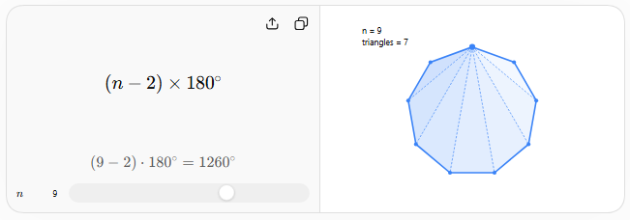
$$S=\left(9-2\right)×{180}^{∘} \\ \boxed{S={1260}^{∘}}$$
Thus, the sum of the nine interior angles of every nonagon is ${1260}^{∘}$.
For a regular nonagon:
$$\boxed{\text{Each interior angle}={140}^{∘}}$$

Number of Diagonals
# Source: AI Source: Provided by: [Data Path: Persons Table -> ID Column: 1, Name_En Column: Motasem Essam] -> From: [ChatGPT] on [7/25/2026]
The number of diagonals of an $n$-sided polygon is:
$$D=\frac{n\left(n-3\right)}{2}$$
For a nonagon:
$$D=\frac{9\left(9-3\right)}{2} \\ D=\frac{9\left(6\right)}{2} \\ \boxed{D=27}$$
From each vertex, the number of diagonals is:
$$9-3=\boxed{6}$$

Triangulation
# Source: AI Source: Provided by: [Data Path: Persons Table -> ID Column: 1, Name_En Column: Motasem Essam] -> From: [ChatGPT] on [7/25/2026]
A convex nonagon can be divided into:
$$n-2=9-2 \\ \boxed{7\text{ triangles}}$$
Therefore, its interior-angle sum can also be calculated as:
$$7×{180}^{∘}=\boxed{{1260}^{∘}}$$

Regular Nonagon Measurements
# Source: AI Source: Provided by: [Data Path: Persons Table -> ID Column: 1, Name_En Column: Motasem Essam] -> From: [ChatGPT] on [7/25/2026]
For a regular nonagon with side length $a$:
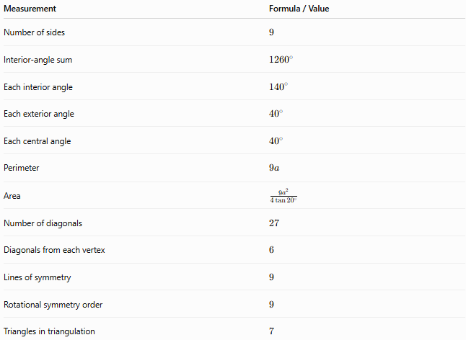
Measurement | Formula / Value
Number of sides | $$9$$
Interior-angle sum | $${1260}^{∘}$$
Each interior angle | $${140}^{∘}$$
Each exterior angle | $${40}^{∘}$$
Each central angle | $${40}^{∘}$$
Perimeter | $$9a$$
Area | $$\frac{9a^{2}}{4\tan{{20}^{∘}}}$$
Number of diagonals | $$27$$
Diagonals from each vertex | $$6$$
Lines of symmetry | $$9$$
Rotational symmetry order | $$9$$
Triangles in triangulation | $$7$$

Example
# Source: AI Source: Provided by: [Data Path: Persons Table -> ID Column: 1, Name_En Column: Motasem Essam] -> From: [ChatGPT] on [7/25/2026]
Suppose a regular nonagon has side length:
$$a=4$$
Perimeter
$$P=9a \\ P=9\left(4\right) \\ \boxed{P=36}$$
Interior Angle
$$\boxed{{140}^{∘}}$$
Interior-Angle Sum
$$\boxed{{1260}^{∘}}$$
Number of Diagonals
$$\boxed{27}$$
Area
$$A=\frac{9{\left(4\right)}^{2}}{4\tan{{20}^{∘}}} \\ A=\frac{36}{\tan{{20}^{∘}}} \\ \boxed{A≈98.90}$$

Real-World Examples
# Source: AI Source: Provided by: [Data Path: Persons Table -> ID Column: 1, Name_En Column: Motasem Essam] -> From: [ChatGPT] on [7/25/2026]
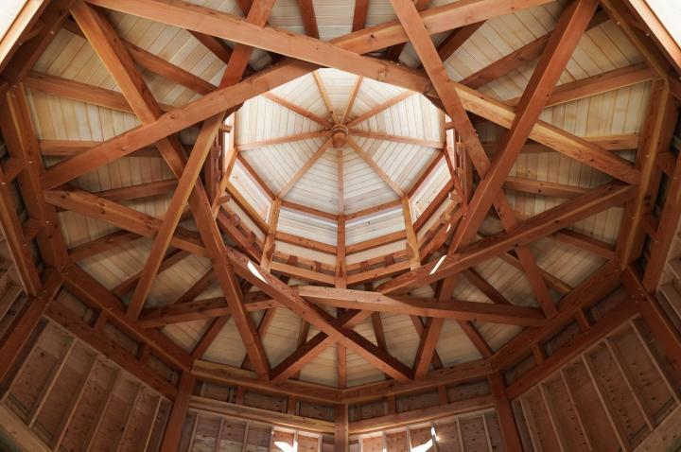
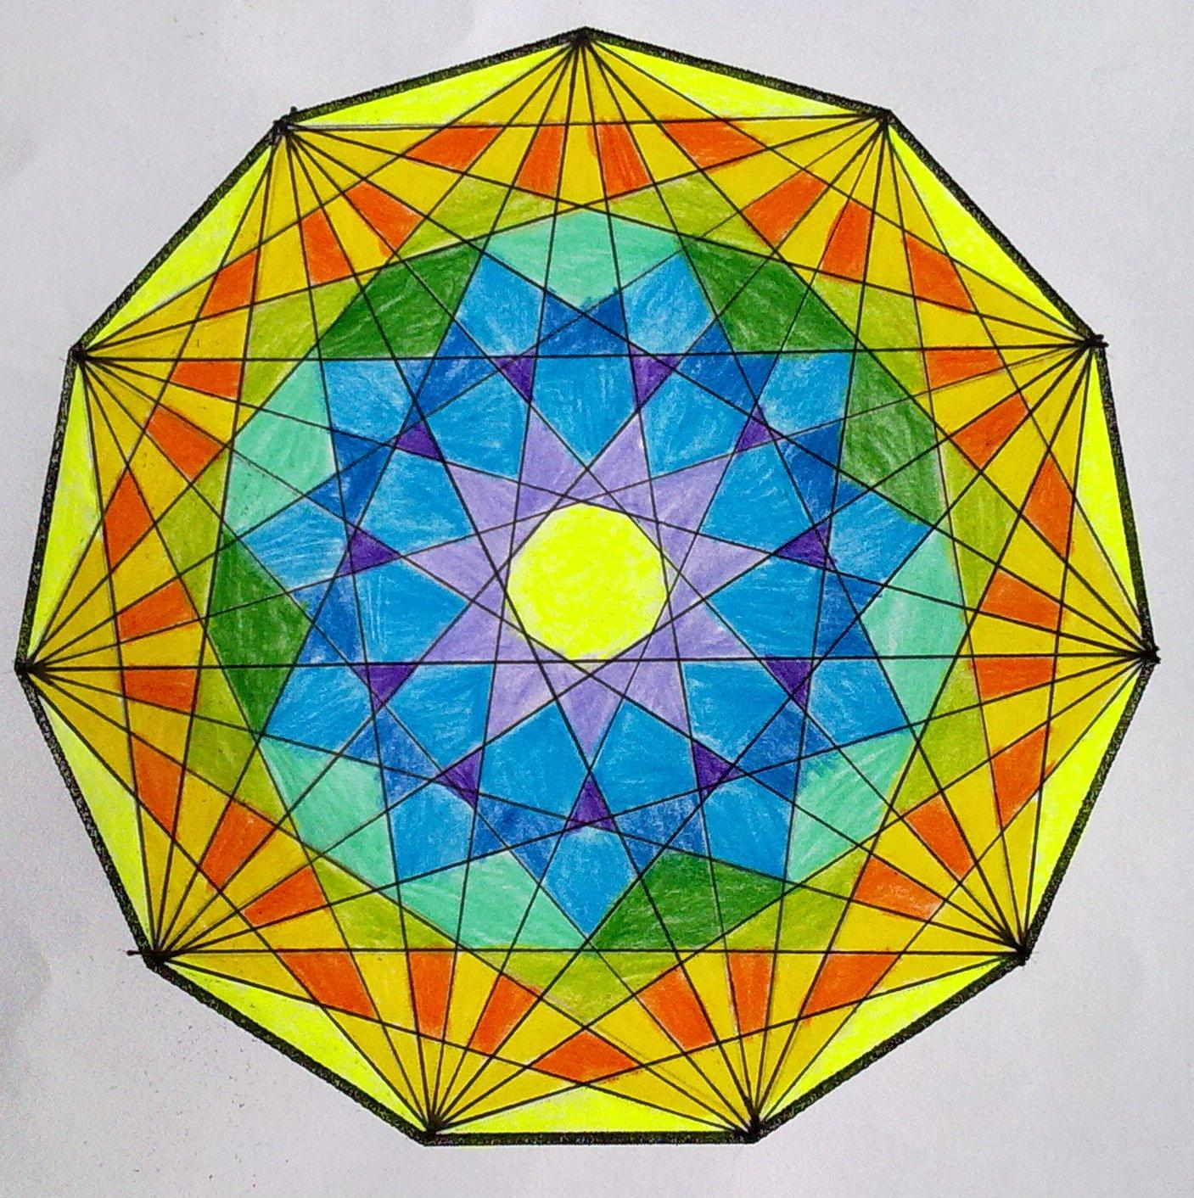
Nonagonal shapes can appear in:
- Architectural designs
- Decorative patterns
- Floor and tile designs
- Logos
- Art and geometric patterns
- Specialized structures
- Computer graphics and geometric modeling

Relationship to Other Polygons
# Source: AI Source: Provided by: [Data Path: Persons Table -> ID Column: 1, Name_En Column: Motasem Essam] -> From: [ChatGPT] on [7/25/2026]
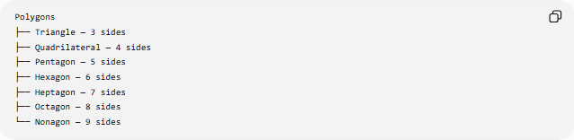
Polygons
├── Triangle — 3 sides
├── Quadrilateral — 4 sides
├── Pentagon — 5 sides
├── Hexagon — 6 sides
├── Heptagon — 7 sides
├── Octagon — 8 sides
└── Nonagon — 9 sides
A nonagon follows the general polygon formulas:
$$\boxed{S=\left(n-2\right){180}^{∘}}$$
and
$$\boxed{D=\frac{n\left(n-3\right)}{2}}$$
For $n=9$:
$$S={1260}^{∘} \\ D=27$$

Key Points
# Source: AI Source: Provided by: [Data Path: Persons Table -> ID Column: 1, Name_En Column: Motasem Essam] -> From: [ChatGPT] on [7/25/2026]
- A nonagon has 9 sides.
- It has 9 vertices and 9 interior angles.
- Its interior-angle sum is ${1260}^{∘}$.
- A regular nonagon has interior angles of ${140}^{∘}$.
- Each exterior angle of a regular nonagon is ${40}^{∘}$.
- Each central angle of a regular nonagon is ${40}^{∘}$.
- A nonagon has 27 diagonals.
- 6 diagonals originate from each vertex.
- A convex nonagon can be divided into 7 triangles.
- A regular nonagon has 9 lines of symmetry.
- A regular nonagon has rotational symmetry of order 9.

Conclusion
# Source: AI Source: Provided by: [Data Path: Persons Table -> ID Column: 1, Name_En Column: Motasem Essam] -> From: [ChatGPT] on [7/25/2026]
A nonagon is a nine-sided polygon. Like other polygons, it can be classified by convexity, regularity, and symmetry. The regular nonagon has nine equal sides and angles, ${140}^{∘}$interior angles, ${40}^{∘}$exterior and central angles, 27 diagonals, and 9-fold rotational symmetry.

